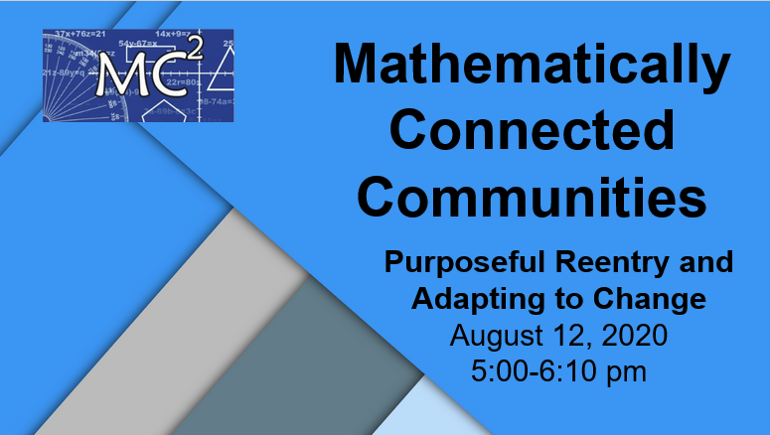
Please note, this is a shared document as well as many of these links are shared documents. To edit or make changes, please make a copy of this page or a specific resource or download it into a program of your choice. See the second page with instructions on how to do this.Slideshow:https://docs.google.com/presentation/d/1fBAGQHDpgYeRuIGlK_G2MduUamvL1a5mEmHMm3P2Di0/edit?usp=sharing

Additional Resources and Links

Link to just specific section of Culturally and Linguistically Responsive Instruction: https://drive.google.com/file/d/17x3dVmpR-KpVzGCtm7kTpN9OZ3k5c_K2/view?usp=sharing

Link to Full Document of Instruction/Overview Section 1 of the NMPED Reentry Documents: https://drive.google.com/file/d/1yt58aIFNp8qj7bnymRNYep_yTaCpsRlW/view?usp=sharing

Link to YouCubed Math Cards Task: https://www.youcubed.org/tasks/math-cards/

Link to Desmos Math Cards Task: https://student.desmos.com/join/fp8tab

Successful Digital Learning from WestEd (1 page): https://drive.google.com/file/d/10OcfJxh7fCYYnqBsIhDKvs5jw3TU_Vf9/view?usp=sharing

Link to Teacher-Created SBLE Lesson Plans (Just add math!) Template for the First 5: https://docs.google.com/document/d/1ozTrUzTaYFqFYnbstSovVP1b-AYIQ6HhVcAeqnw74RI/edit?usp=sharing

Link to Corwin Press and works by Susan Loucks-Horsley: https://us.corwin.com/en-us/nam/author/susan-loucks-horsley

Instructional Scope for Mathematics (Where to Start): https://docs.google.com/document/d/1qvJwgji5ZUi1PZjhOubbZPUDWs6nkDRBK0i0YmOkkb0/edit?usp=sharing

Link to MC² Website: https://mc2.nmsu.edu/
Link to MC² Professional Learning: https://mc2.nmsu.edu/pd/
Link to MC² Contact Page: https://mc2.nmsu.edu/about-us/contact-us/

Thank you for your work and dedication to New Mexico students and families!

Make a Copy or Download a Shared File

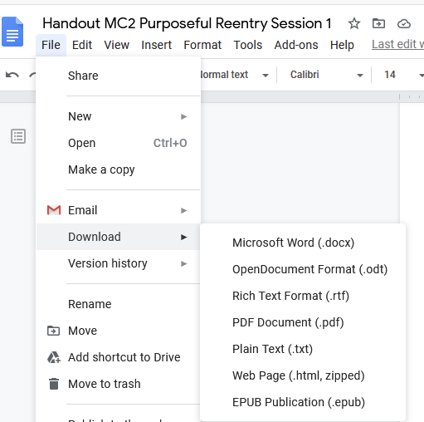

To make a copy, go to File, Make a Copy, and then rename the copied file. Your copy will be in your Shared With Me folder in your Google Drive.

To download it into another program, go to File, Download, and select the program you would like to use and then save it in that program.

